Customer Journey Map – Pattern Sense: Classify Fabrics Using Deep Learning

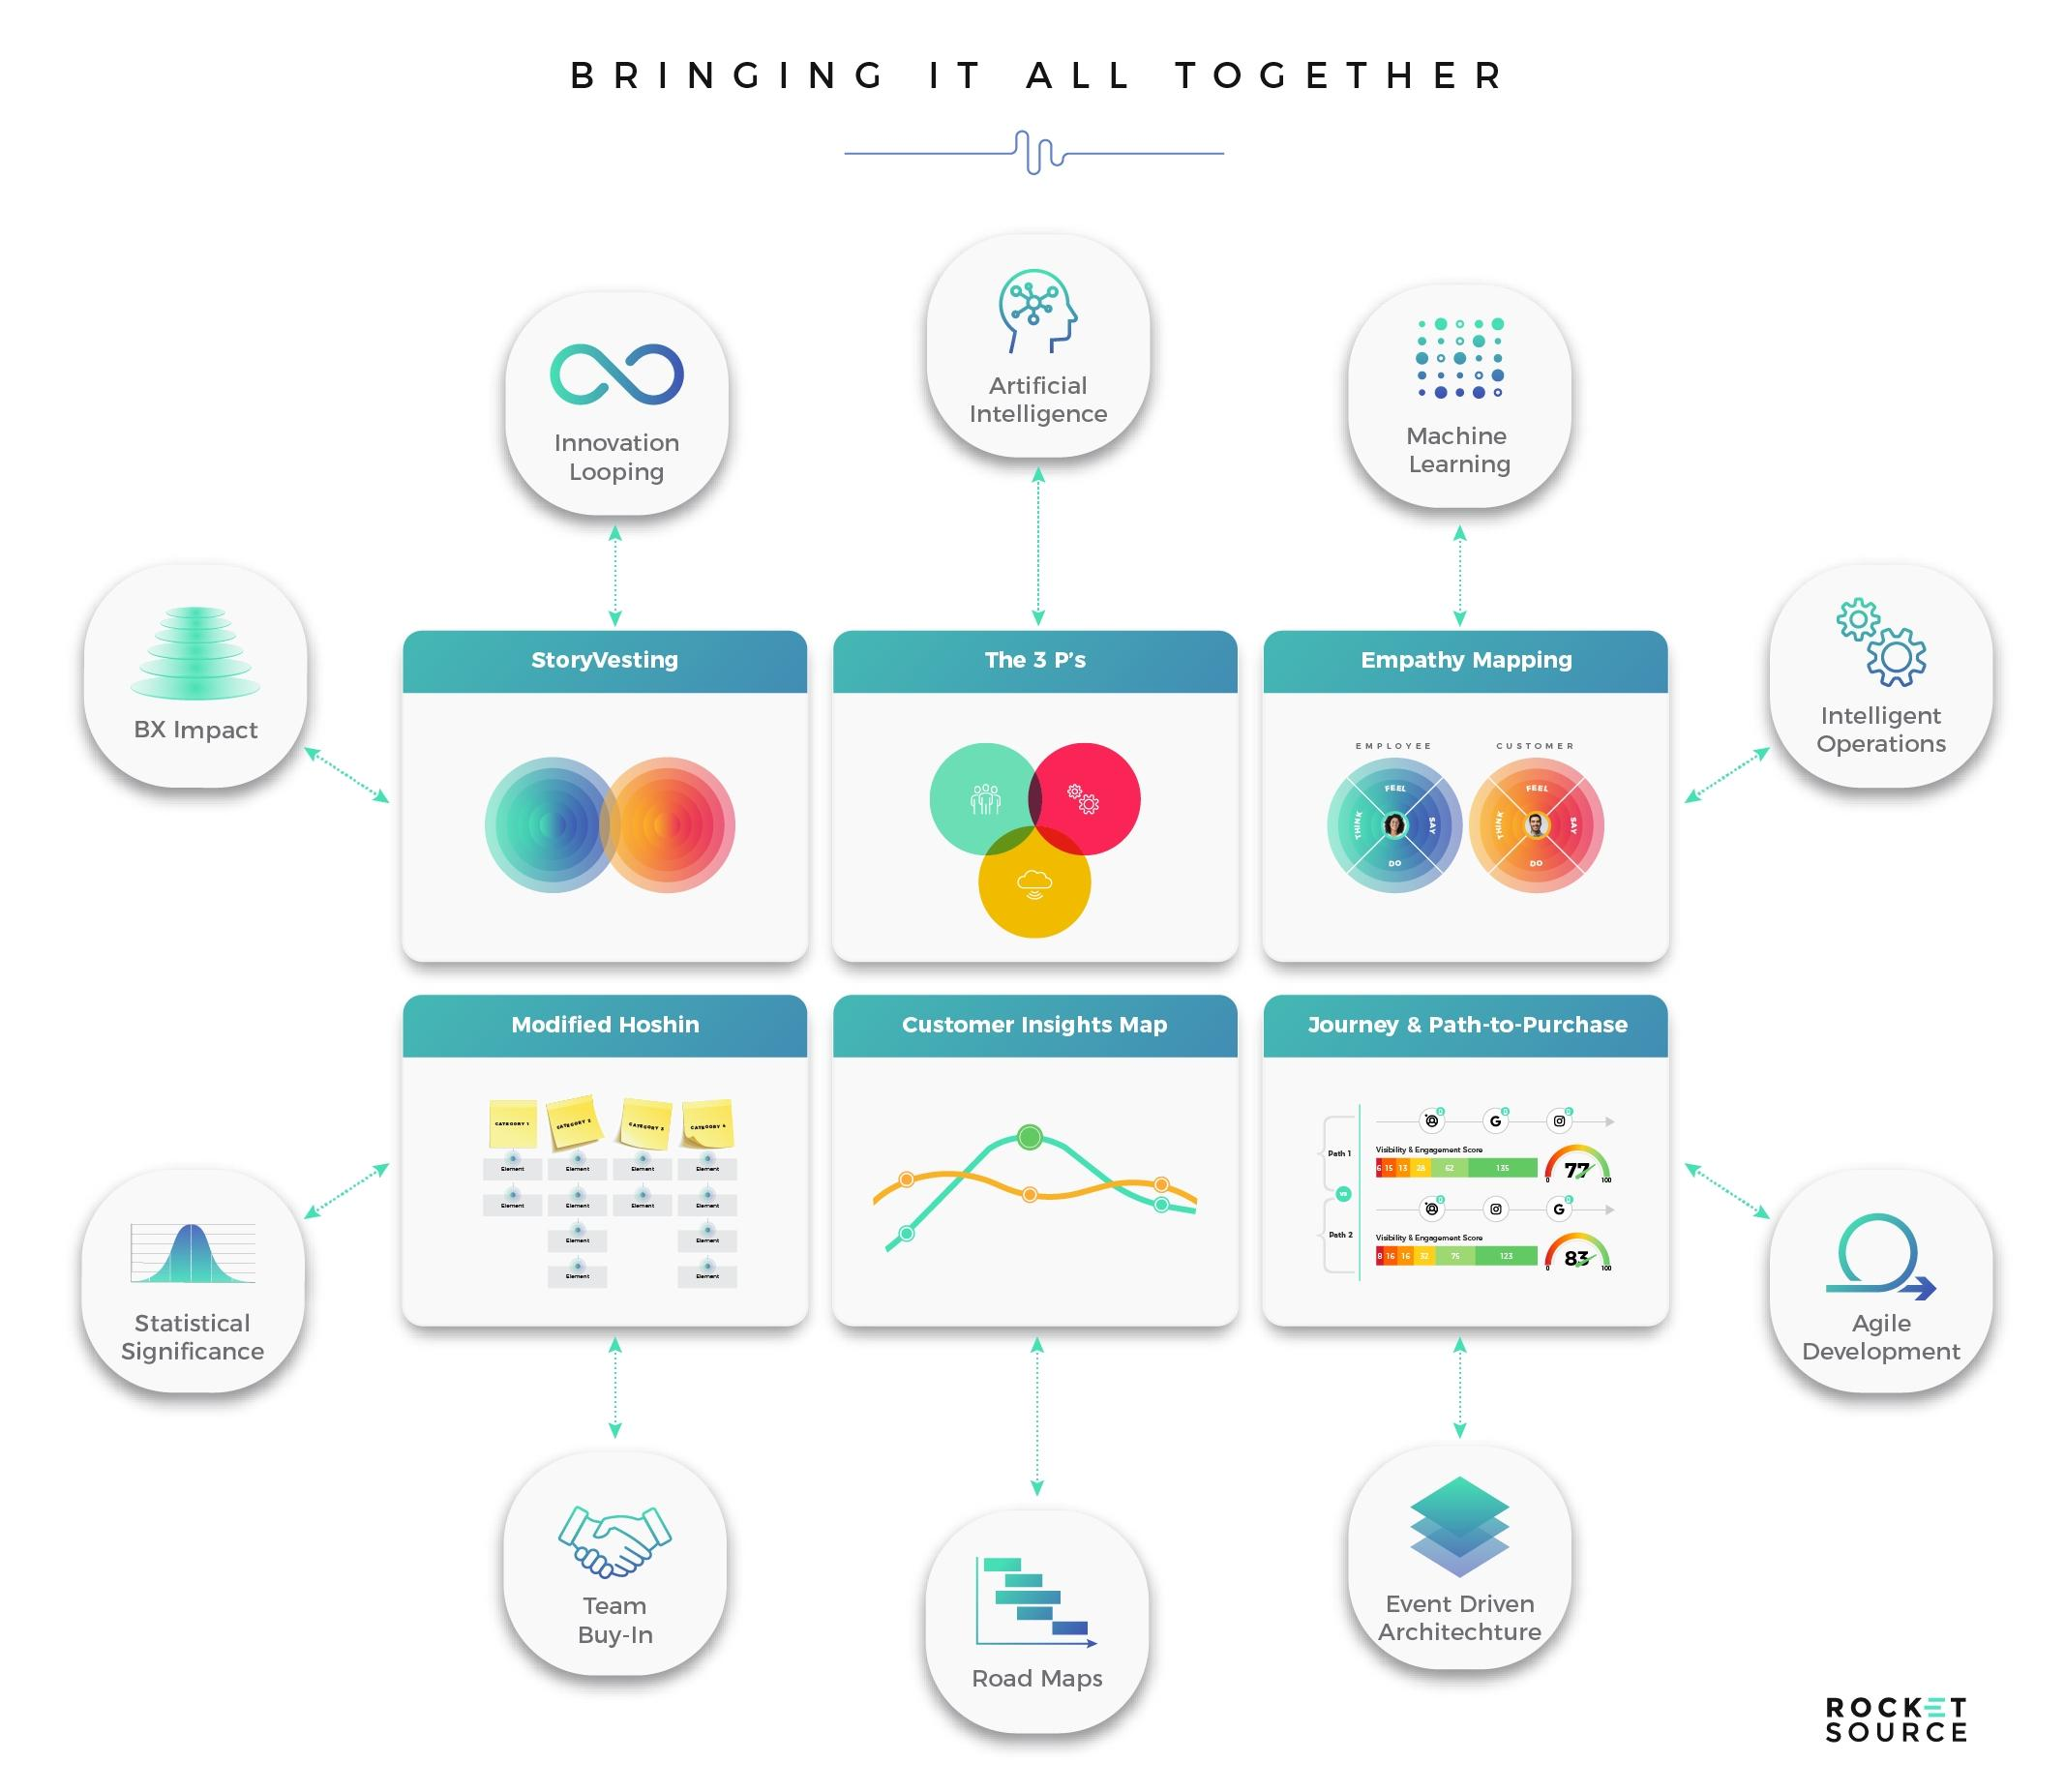**SCENARIO**:

Exploring, uploading, analyzing, and acting on fabric data using a deep learning model

|  |  |  |  |  |  |  |  |  |  |
| --- | --- | --- | --- | --- | --- | --- | --- | --- | --- |
| Stage | Steps | Experience | Touchpoints | Location | People | Goals & Motivations | Positive Moments | Negative Moments | Opportunities |
| Entice | Discover fabric classifier | User becomes aware via blog, research, or industry forums | Website, research article, LinkedIn post | Online | AI/ML community, colleagues | Help me automate fabric type detection | Excitement about AI in fashion/textile | Uncertainty about technical setup | Provide video demo, simple overview |
| Enter | Visit fabric classifier platform | Exploring the web interface or API docs | Web dashboard, API docs | Home/office lab | Solo user, possibly a dev team | Help me see how this works | Clear UI, quick access to model | Too much jargon or dense info | Use tooltips, user onboarding walkthrough |
| Browse | Upload or choose fabric images | Uploads fabric swatches for classification | Image upload feature, drag & drop | Fabric lab, design studio | Designer, technologist | Help me classify fabric types correctly | Simple upload, drag-n-drop ease | File type or size limitations | Offer format converter, batch upload |
| Engage | View classification results | System returns predicted fabric category with confidence level | Model output screen | App/web dashboard | Researcher, production engineer | Help me verify material type quickly | Fast, accurate results | Doubts about prediction confidence | Visual explanation of results (e.g., Grad-CAM) |
| Purchase / Commit | Use model outputs in production | Integrate classification into workflows | Export, API integration | Backend system | Developer, QA team | Help me automate decisions | Smooth API handoff | Integration complexity | Provide SDKs, pre-built pipelines |
| Extend | Improve model, give feedback | Users fine-tune or provide labeled data for improvement | Feedback forms, retraining module | Cloud platform | Data scientist, AI engineer | Help me improve model accuracy | Community-sourced labels, leaderboard | Model errors, lack of retrain options | Add custom training interface, dataset tips |
| Celebrate | Share outcomes or improvements | Case studies, success stories in textile automation | Blog, LinkedIn, conference talk | Online, events | Marketing team, users | Help me showcase innovation | Visibility, recognition | Lack of sharing tools | Enable report generation, templates for showcasing results |